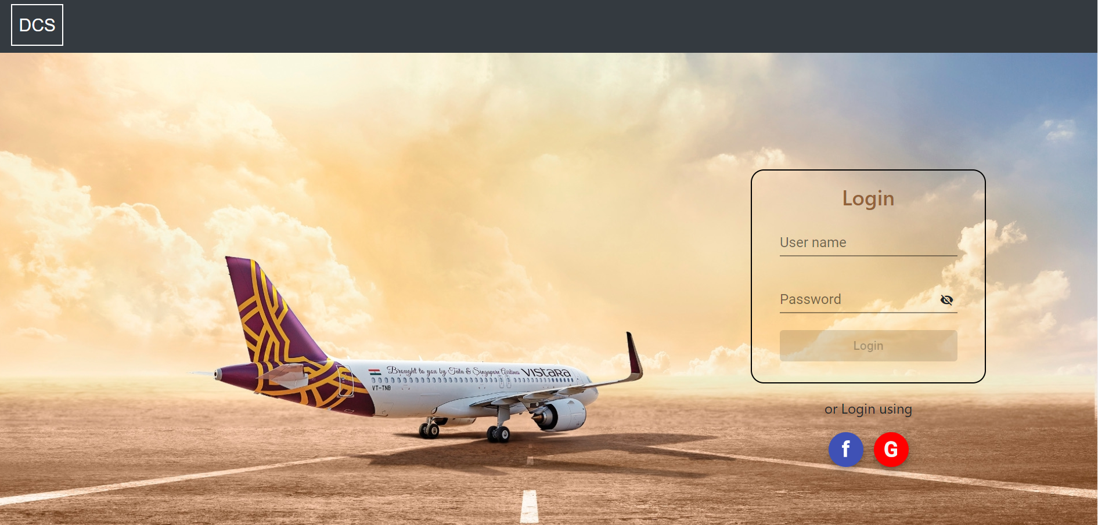

staff or admin can login with valid credentials or using social login feature.

**Admin Credentials** :

username : admin123

password: qwerty

**Staff Credentials:**

username : staff123

password : qwerty

If user login using Social login feature , then user is considered as staff not as admin.

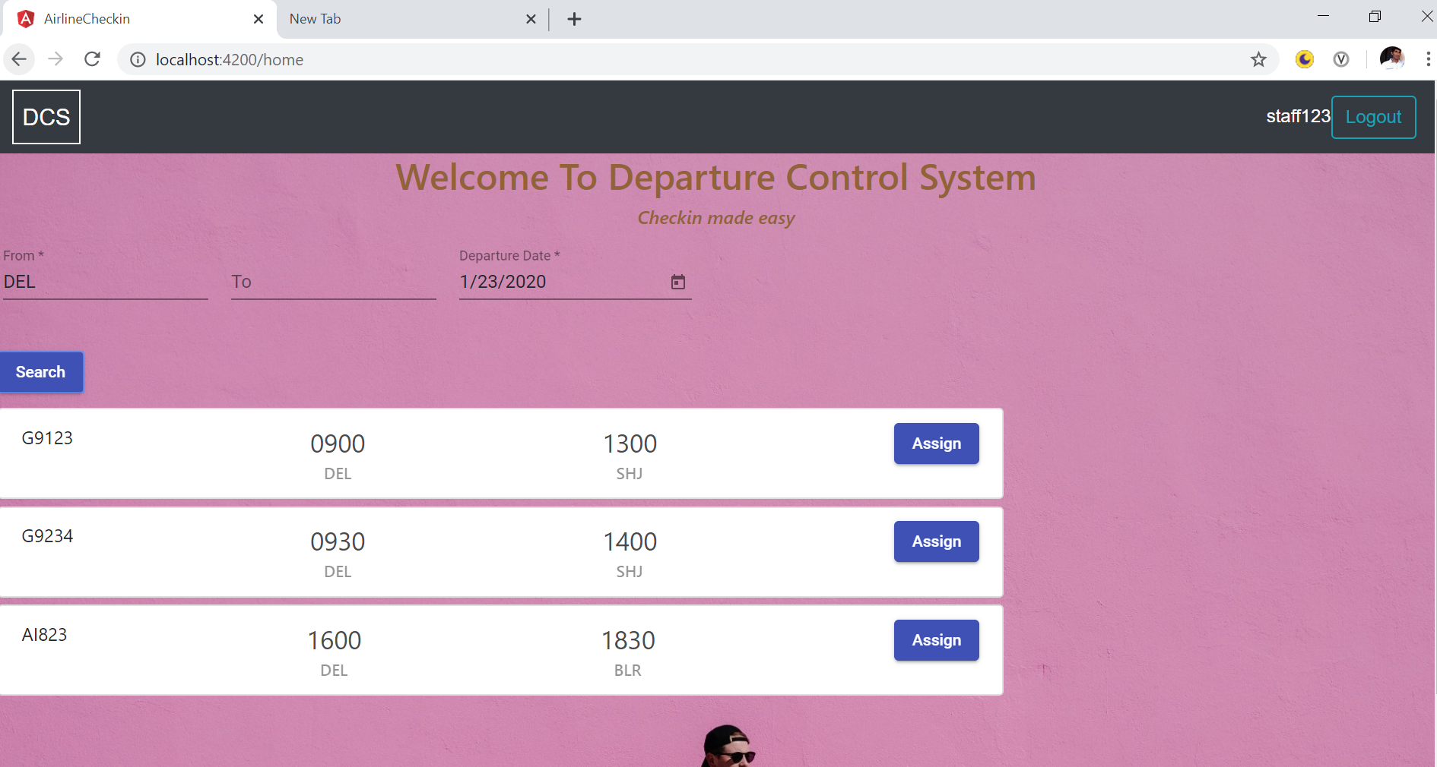

user logged in as staff

After logging in staff or admin can search flights .

Flights are available from DEL to SHJ and DEL to BLR on 23rd jan2020

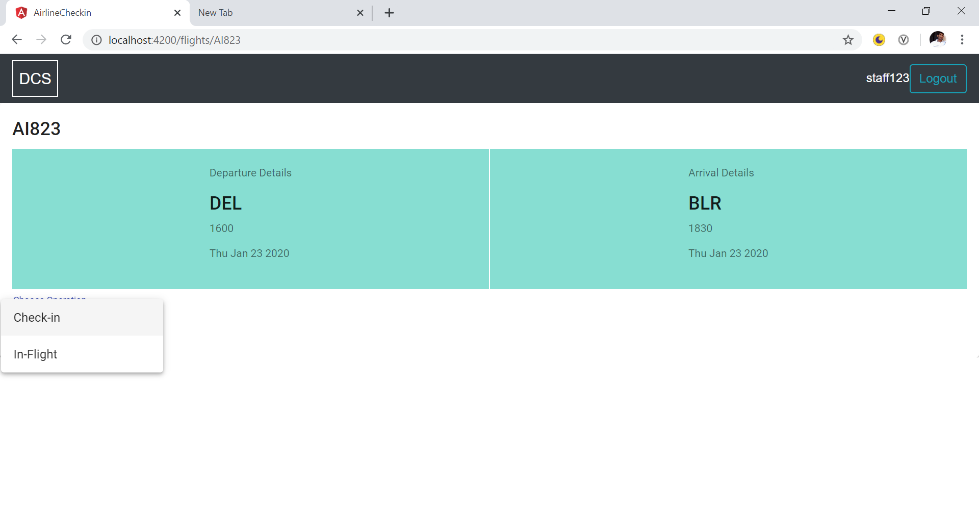After assigning any one flight shown in the previous slide , this screen will be displayed where user can select to checkin or inflight services

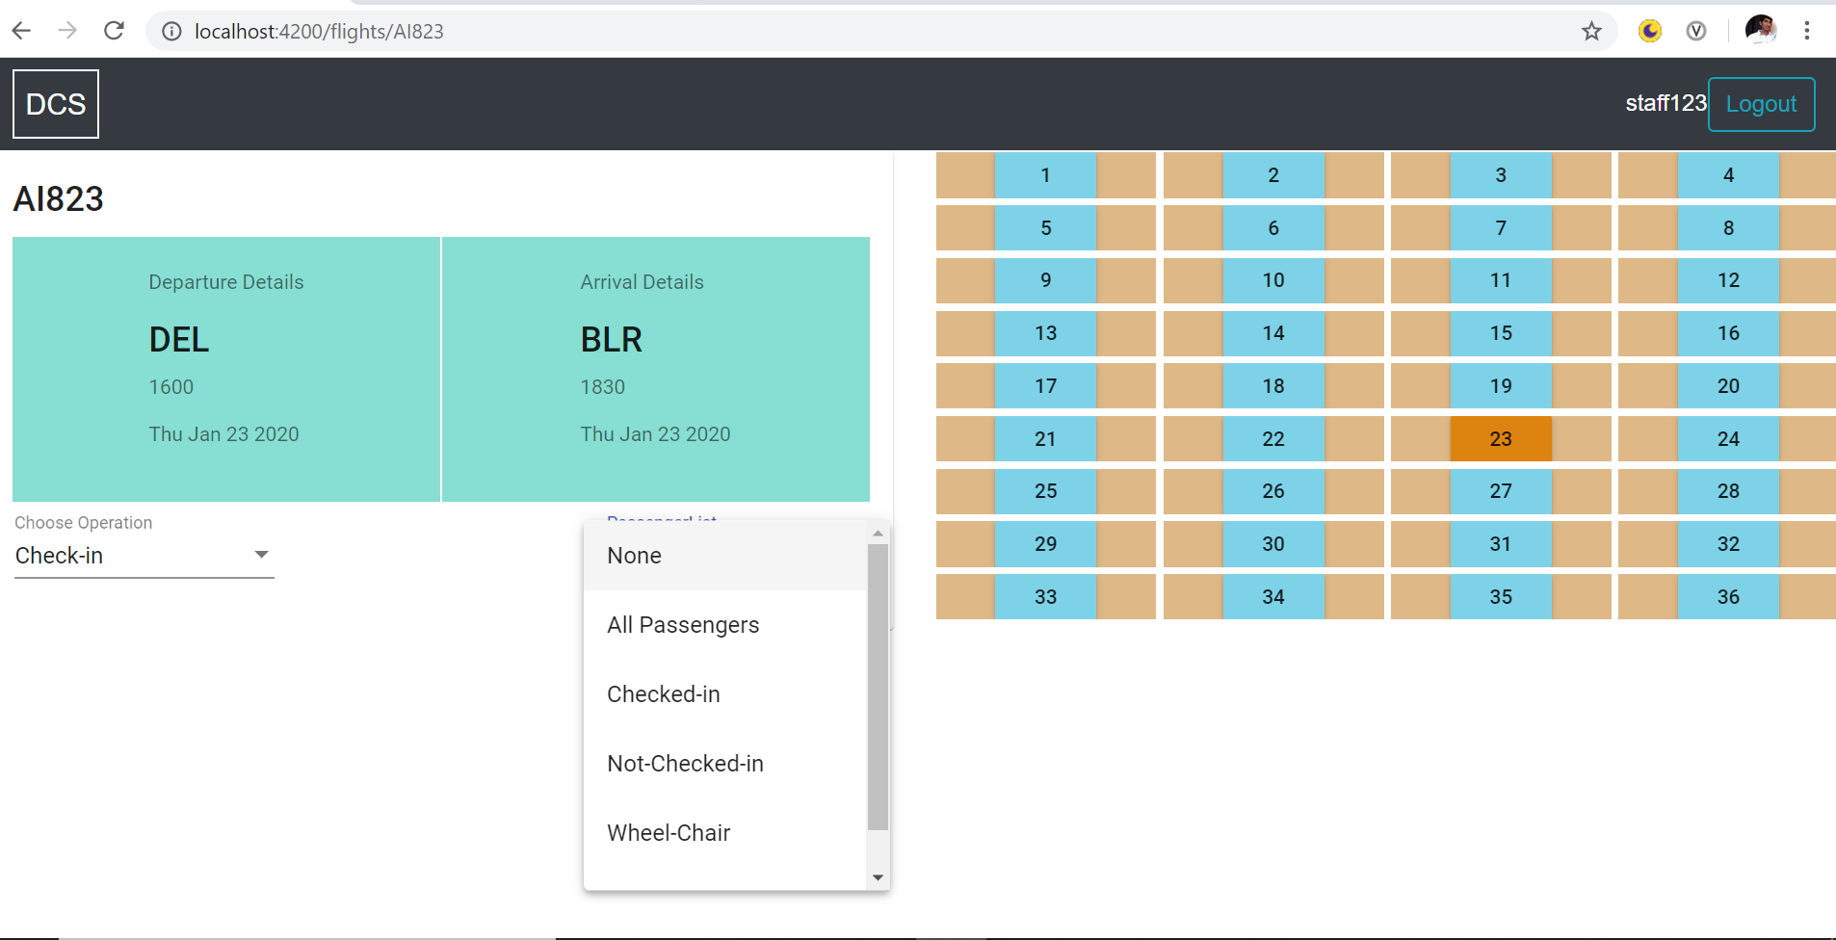

if user selects checkin from drop down then seat- map and a dropdown filters for passengers will be available .

For accepted passengers seat will be allocated and based on passengers are wheel chair or infant associated the seat will be color coded.

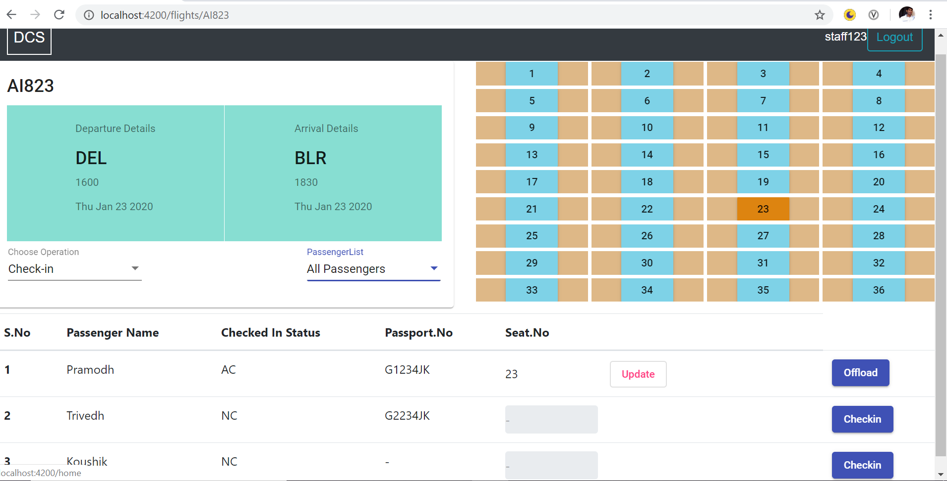

Once user select a filter from drop down , passengers will be displayed with details as shown. From here staff can checkin or offload passengers .In this feature seat will be allocated by the system based on availability.

staff can update seat number for checked in passengers

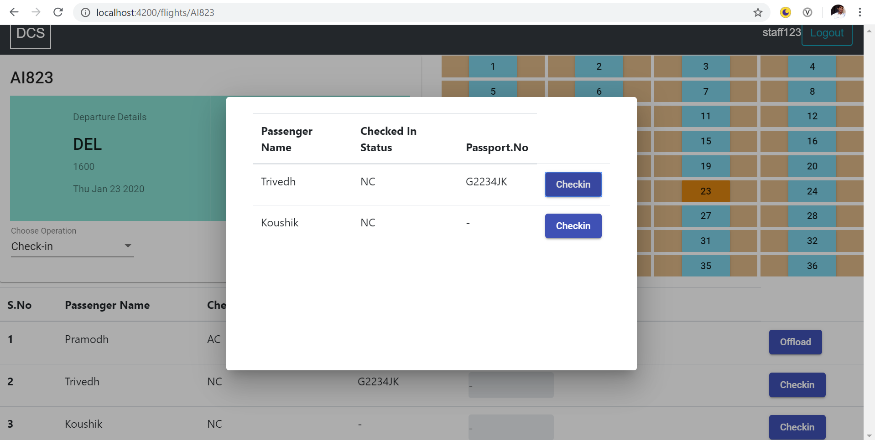

On clicking any available seat , staff will be prompted with a screen to check-in passengers and the respective seat will be allocated for that passenger.

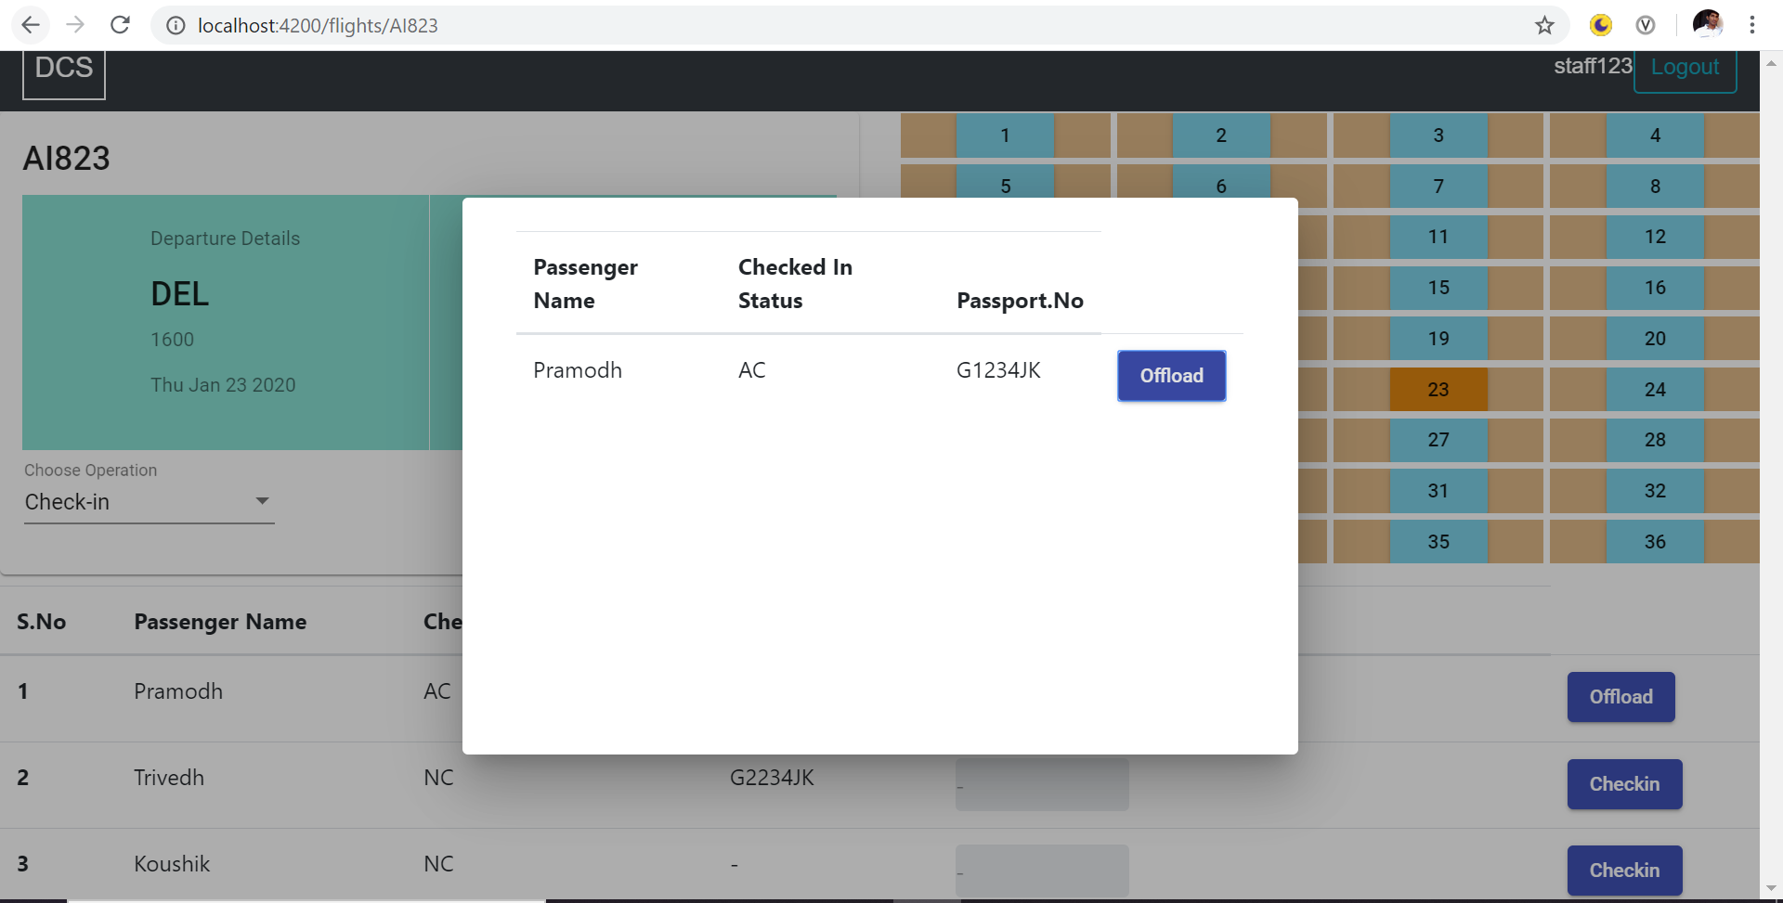

On clicking any occupied seat , staff can offload that passenger to NC status

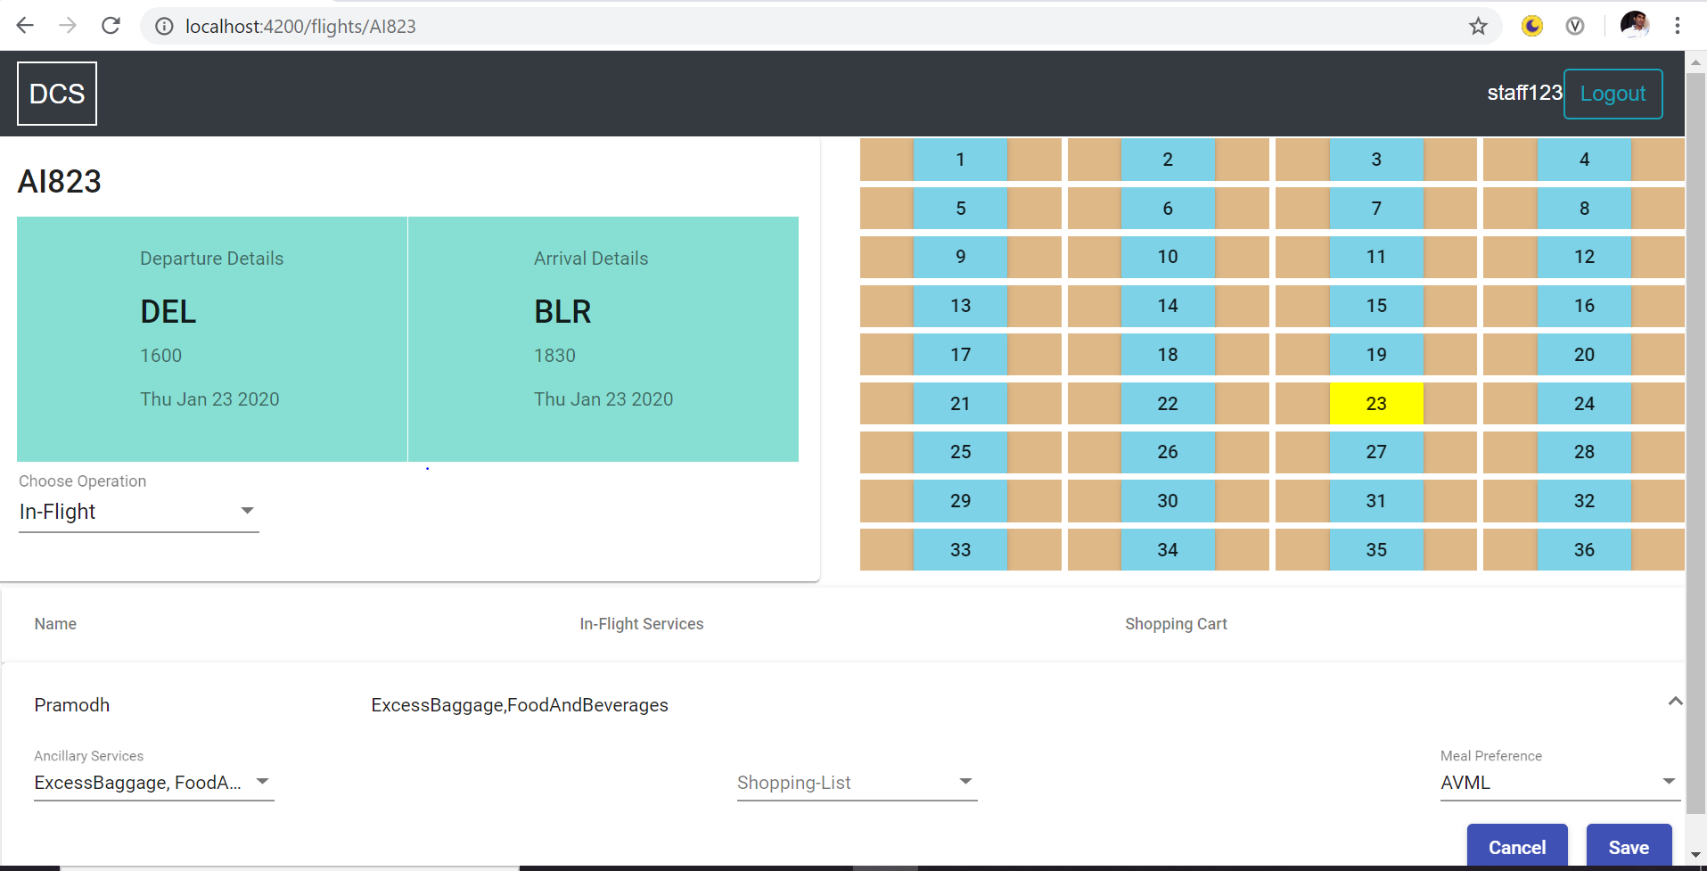

staff can select in-flight from drop down to to add ancillary services and shopping items and can change meal preference for a checked-in passenger

user logged in as admin

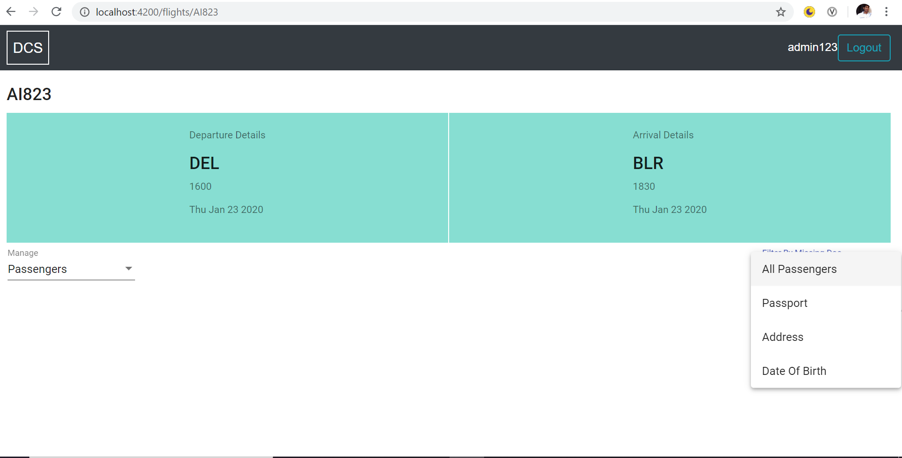

After admin login , admin can filter passenger by missing doc .

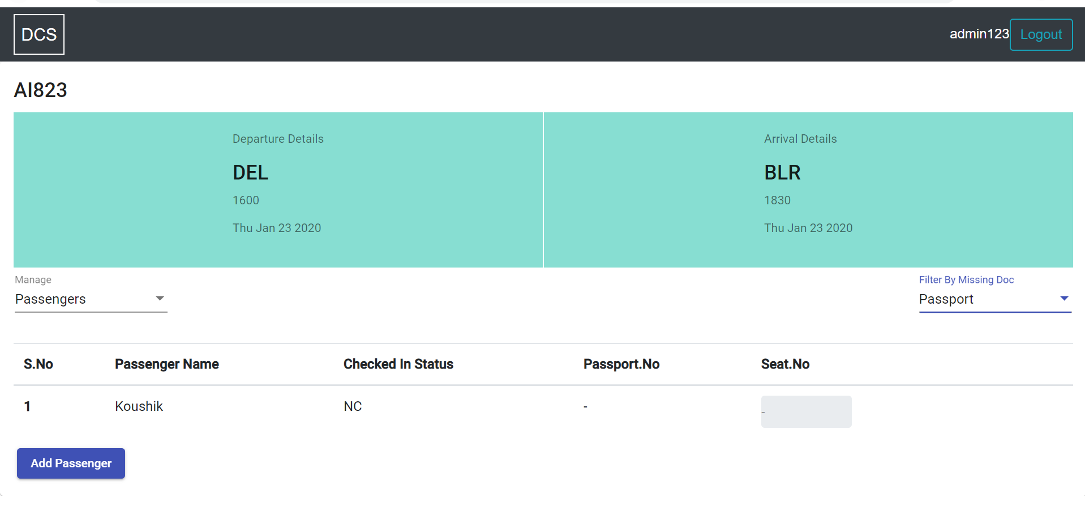

admin can add passenger.

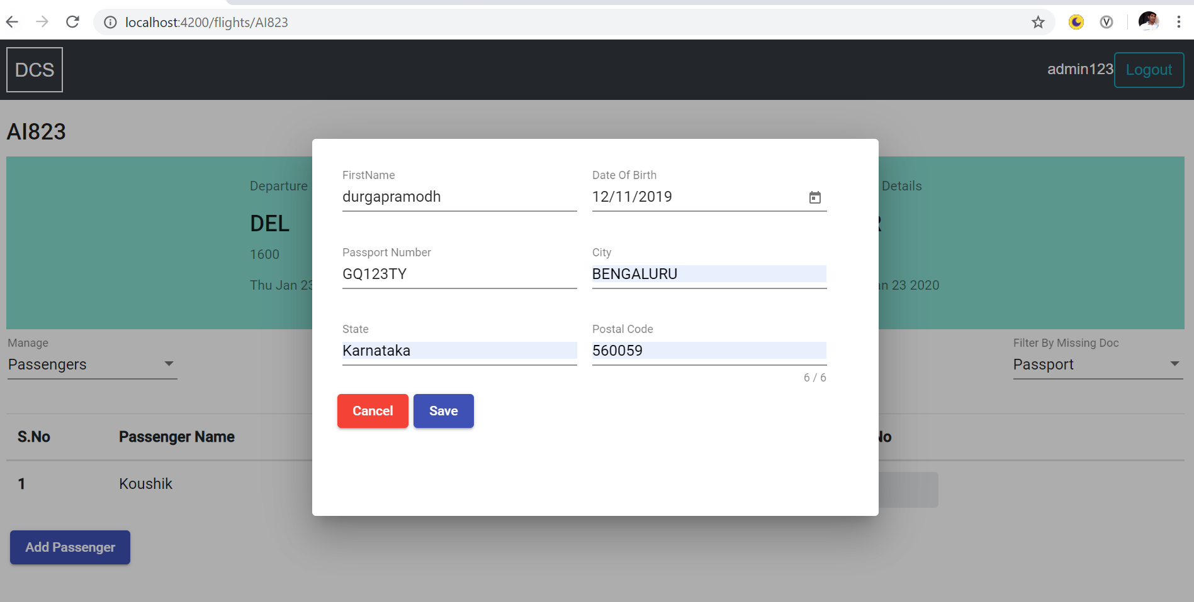

on clicking add passenger.

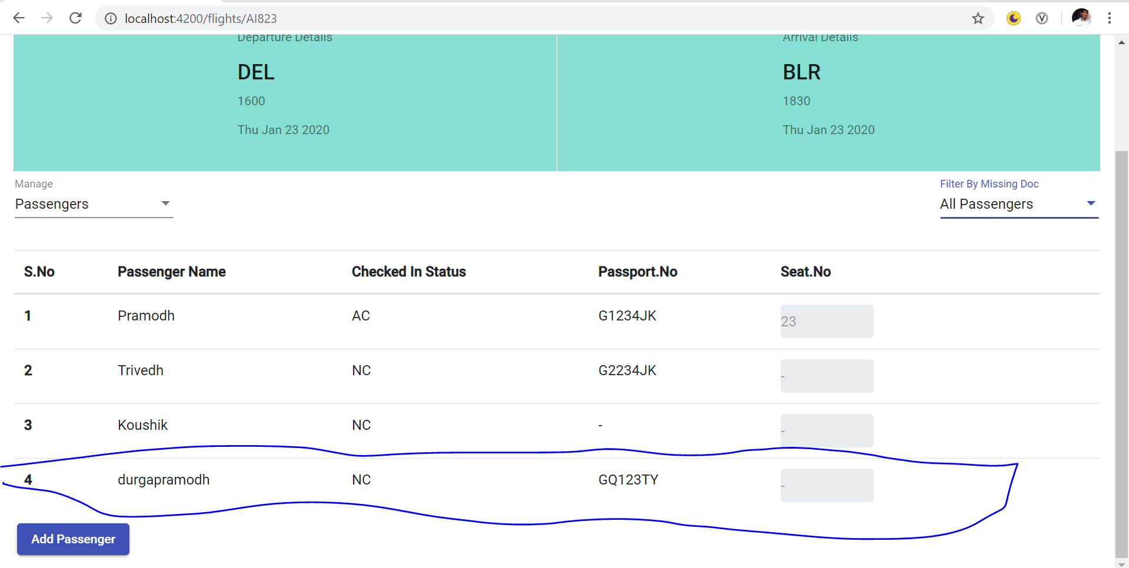

admin can see added passenger in all passengers view.



All files in the project passed linting.

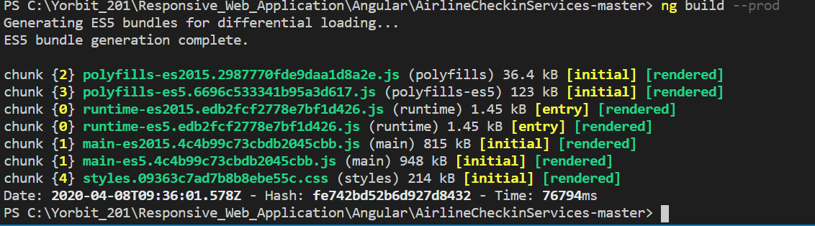

build successful using –prod flag

starting light-weight inbuilt node server to demonstrate offline (progressive app design) working

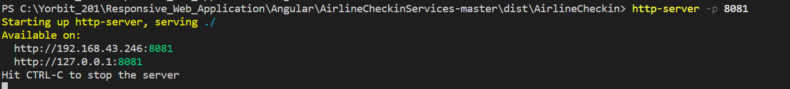

Notice that the app is served from one of the node

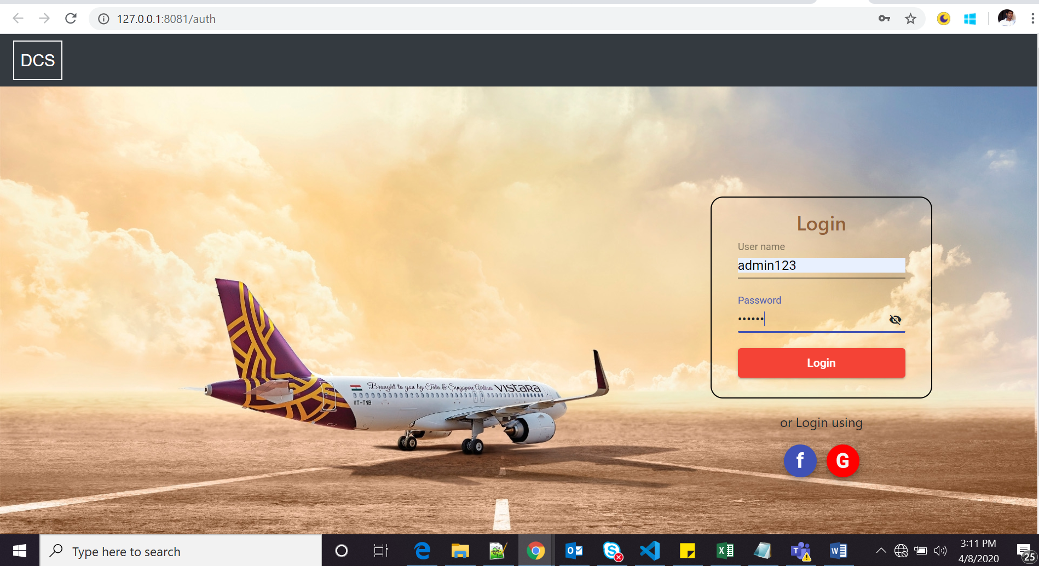

please notice that the system is not connected to internet

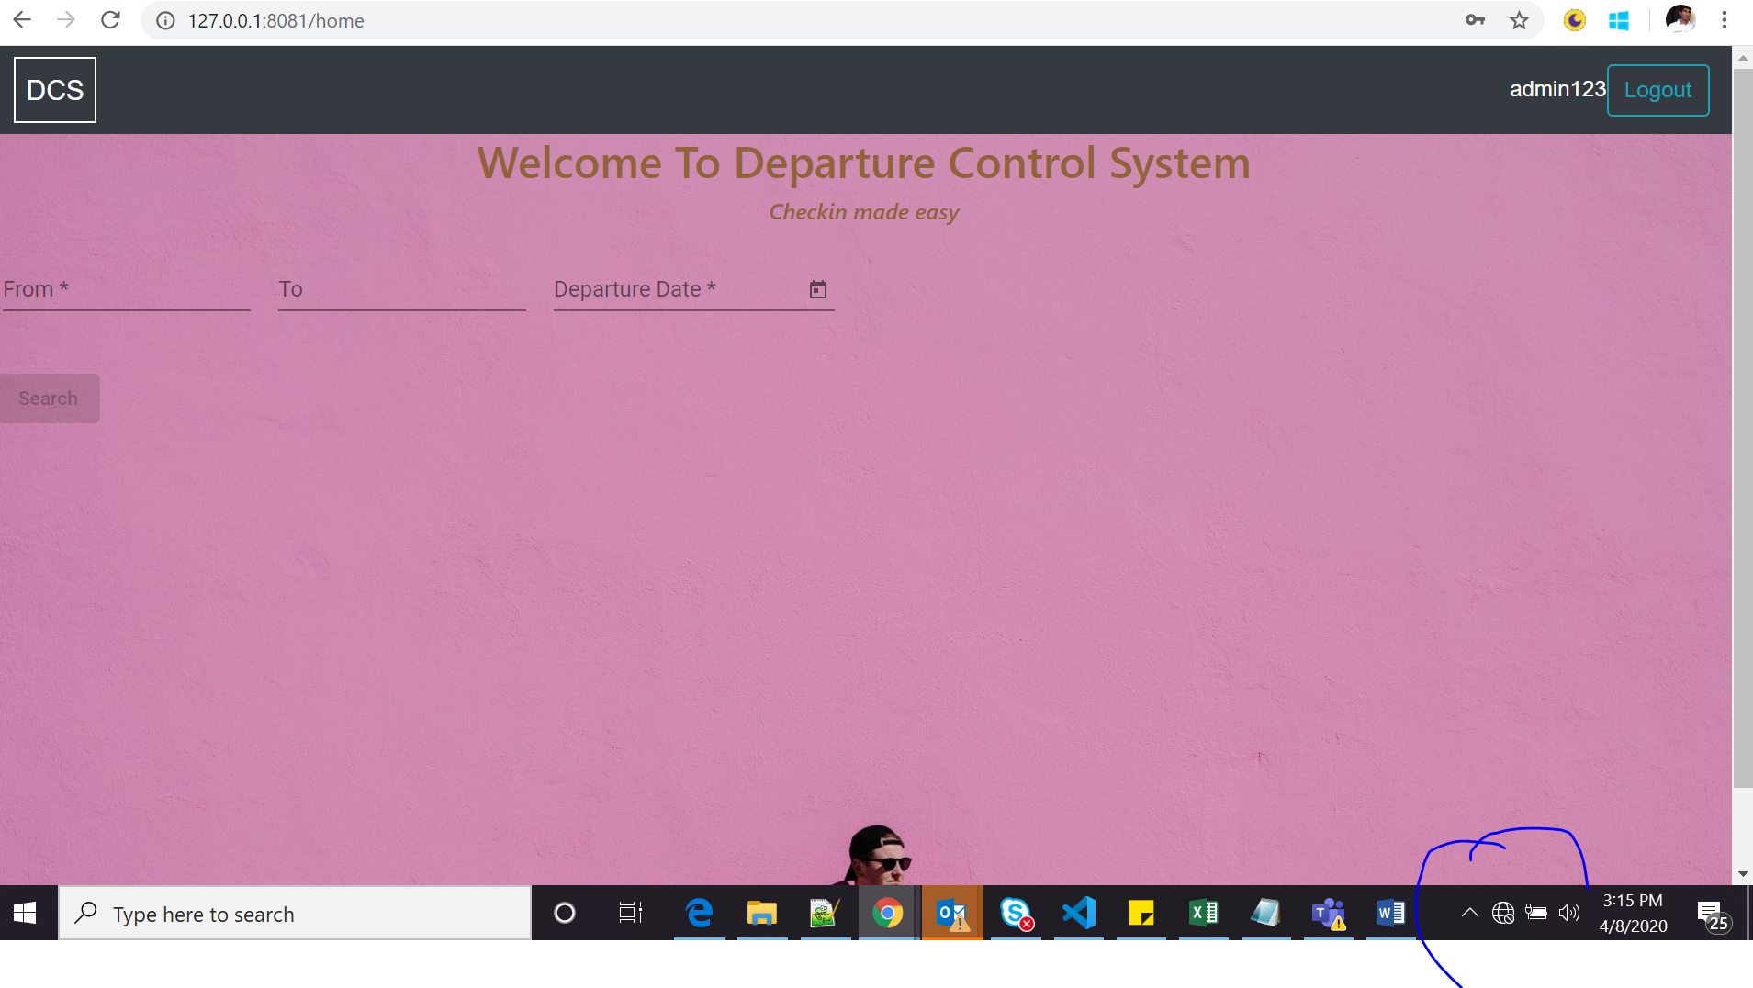

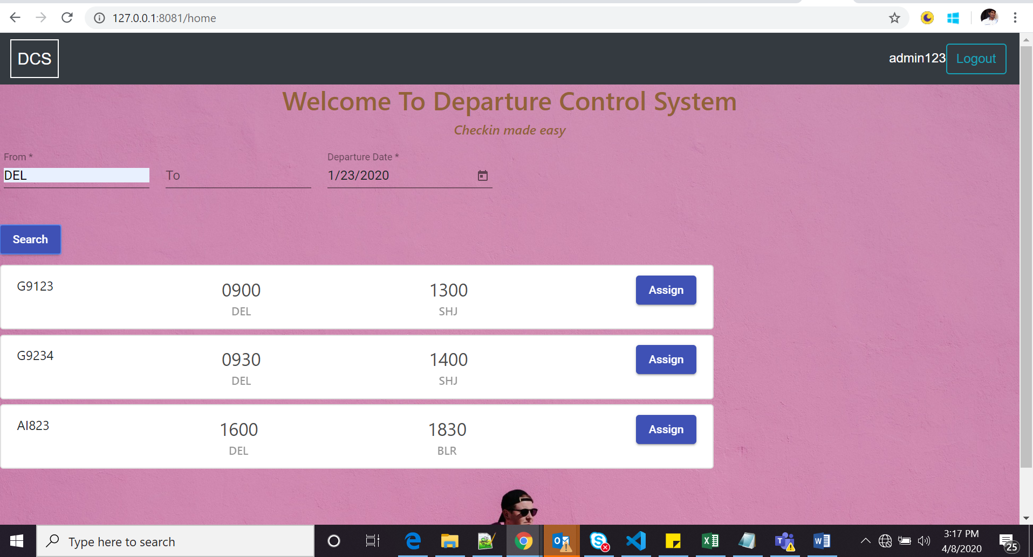

************************************ END *******************************************